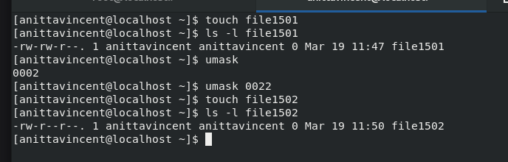
Created a file (file1501), Checked its permissions, Checked the current umask. Changed the umask to 0022, Created a new file (file1502), Checked its permissions
When umask was 0002, permission is : 666 (rw-rw-rw-) -umask 0002 = 664 (rw-rw-r--). So file 1501 has rw-rw-r—permission.
After changing umask to 0022, 666 - 022 ----- 644 → rw-r--r--. So file 1502 has a different permission.

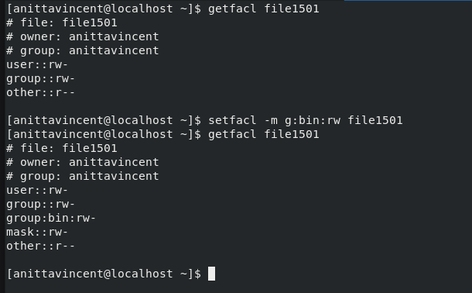
Checked ACLs on file1501, Added an ACL for group bin with read/write permissions, and checked ACLs again.
In the setfacl command added g:bin:rw
This means the group bin now has explicit read/write ACL permission to this file, and This permission is independent of the file’s standard group.
After adding the ACL, the output becomes:
group:bin:rw-
mask::rw-
The mask represents the maximum permission allowed for named groups, named users, the file’s group. So the mask became: mask::rw-

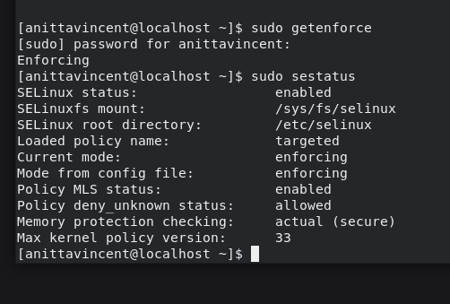
sudo getenforce: Shows the current SELinux mode: Enforcing / Permissive / Disabled. Here the status is Enforcing
sudo sestatus: Displays full SELinux status, including policy, mode, type, and config file settings.

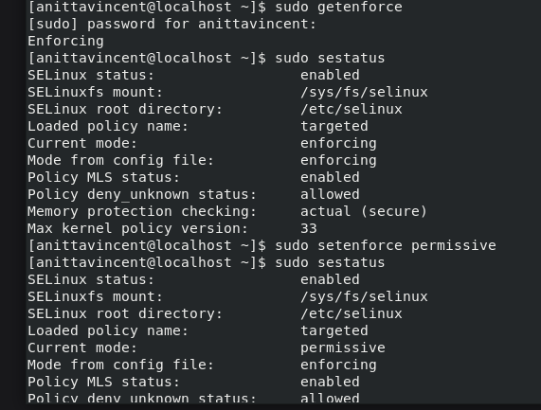
sudo setenforce permissive temporarily switches SELinux to permissive mode at runtime.

sudo setenforce enforcing puts SELinux back into enforcing mode.

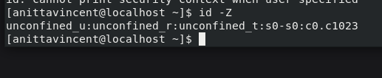
id -Z shows your current SELinux security context, including SELinux user, role, type (domain), and MLS/MCS level.
unconfined_u : SELinux user identity (not restricted).
unconfined_r : SELinux role (allows unconfined domains).
unconfined_t : SELinux process domain (no MAC restrictions).
s0-s0:c0.c1023 : MLS/MCS security range (default category set).

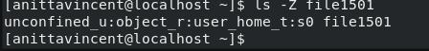
ls -Z file1501 shows the SELinux file security context for file1501.
unconfined_u : SELinux user who owns the file.
object_r : SELinux role for filesystem objects.
user_home_t : SELinux type indicating the file is in a user's home directory.
s0 : MLS/MCS security level for the object.

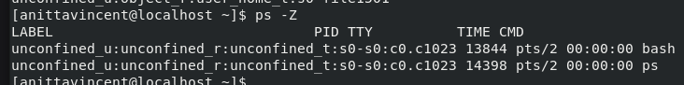
Shows the SELinux security context of each running process.

